**Guideline about Term Project Team Formulation & Data Download**

Deadline: 2020/05/10 23:30

**Part I、Team Formulation**

1. Go to iLMS Teams

* Select Team No. & add your teammates
* Limit: Three Person at least and Five person at most

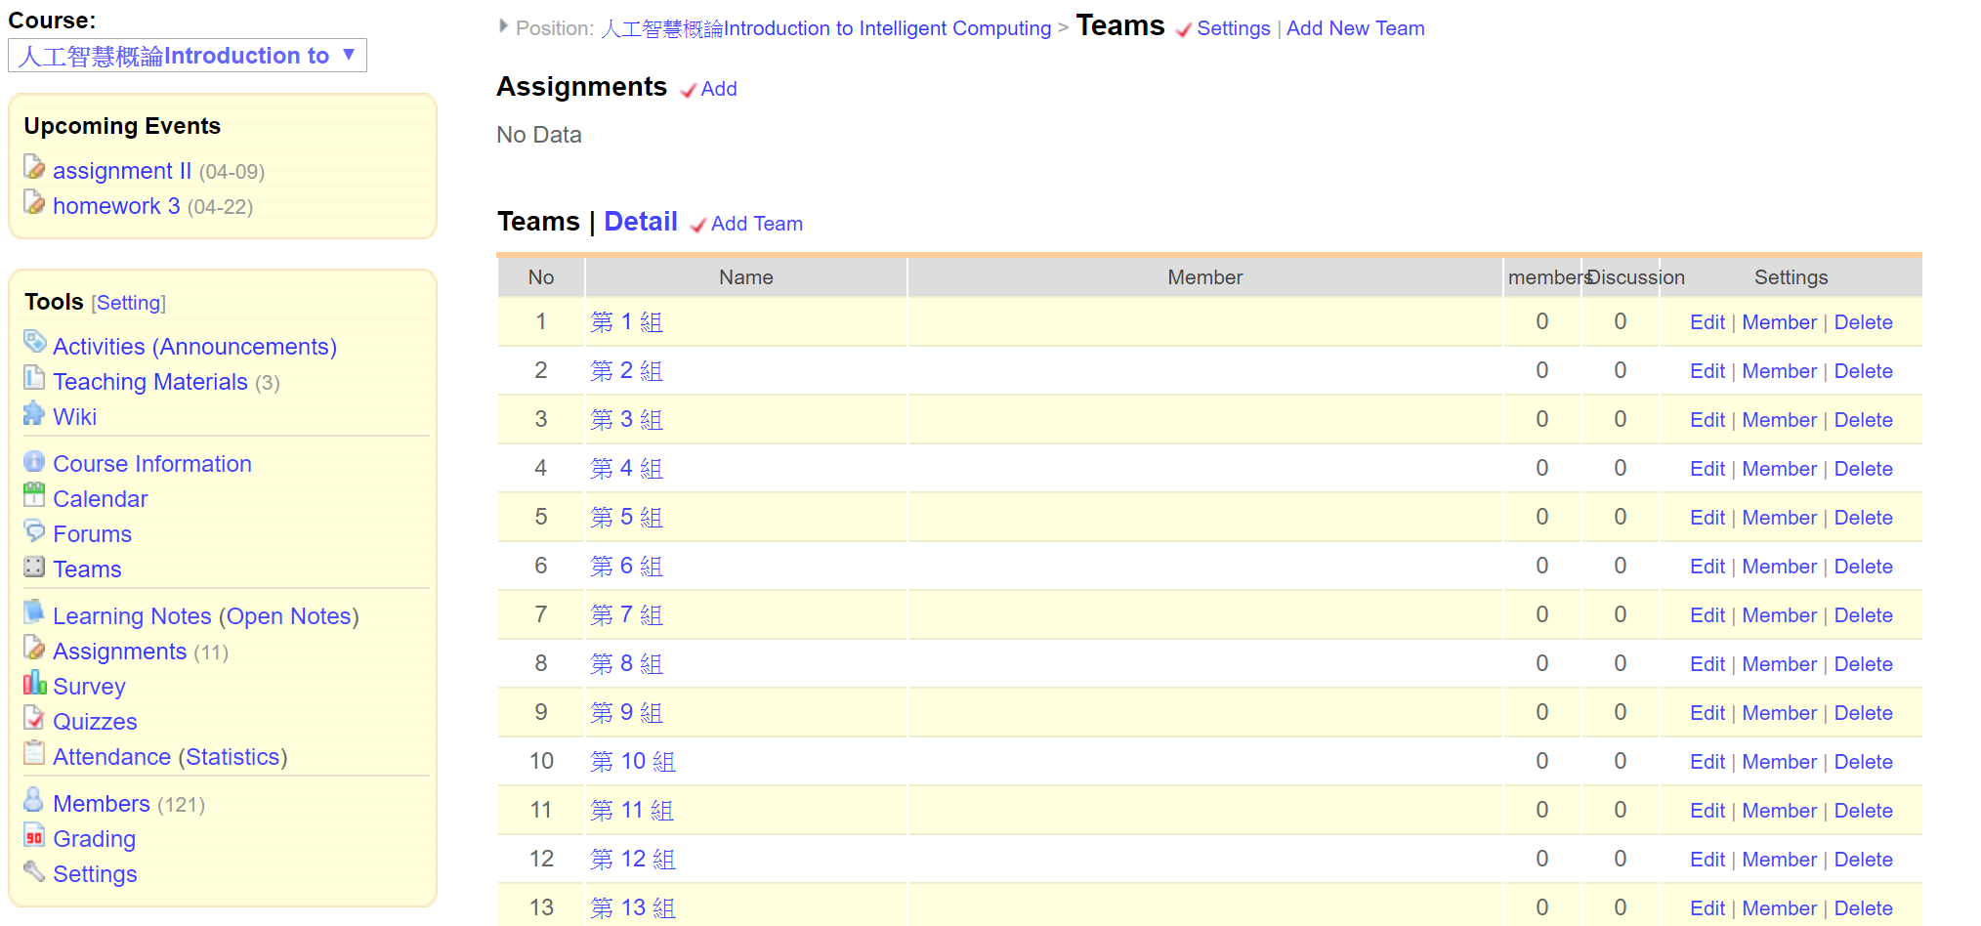

1. Go to competition website – AI mango grade ranking competition

* Website Link: <https://aidea-web.tw/topic/72f6ea6a-9300-445a-bedc-9e9f27d91b1c>

2-1 Register an account

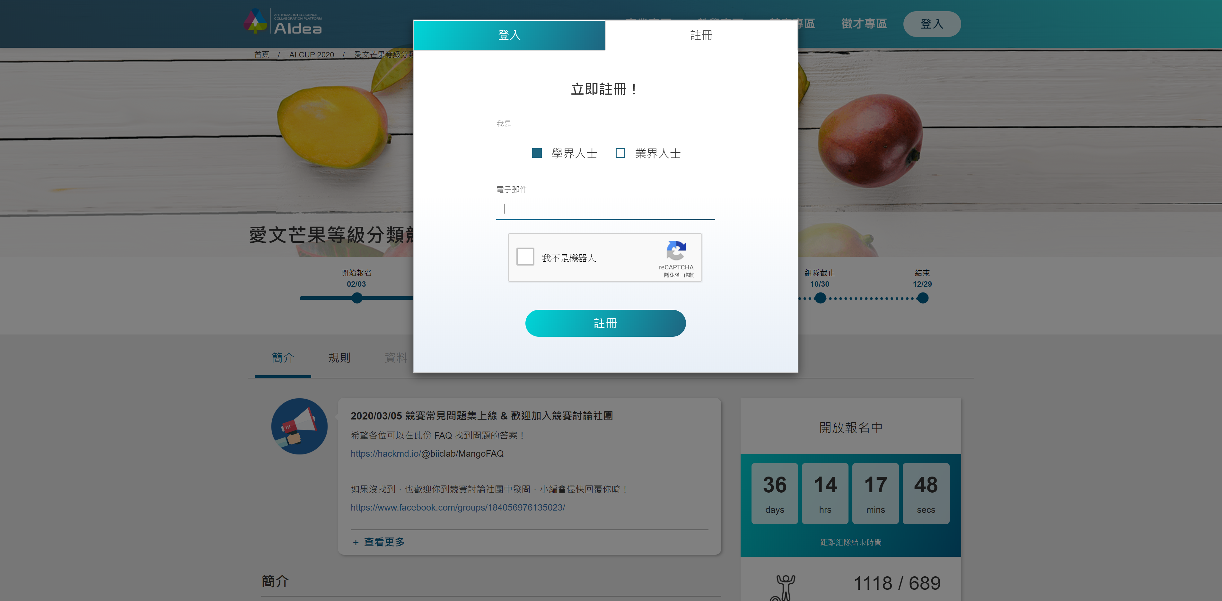

2-2 Team Invitation

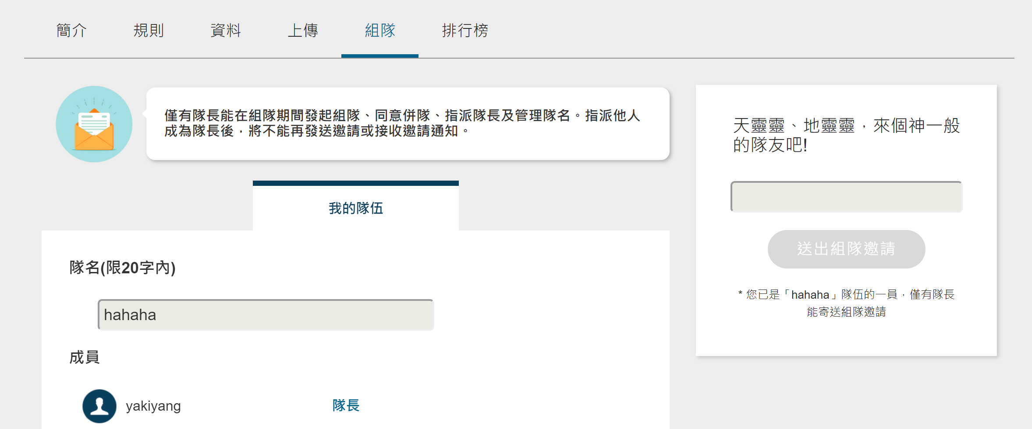

**Part II、Data Download**

